ASSIGNMENT: 1
1. Creating and Renaming Files/Directories
Create a directory named test_dir using mkdir.
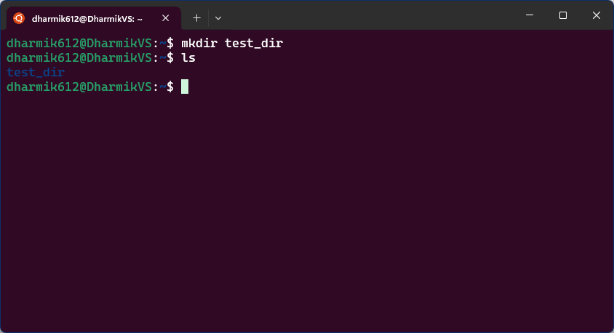
Inside test_dir, create an empty file called example.txt.
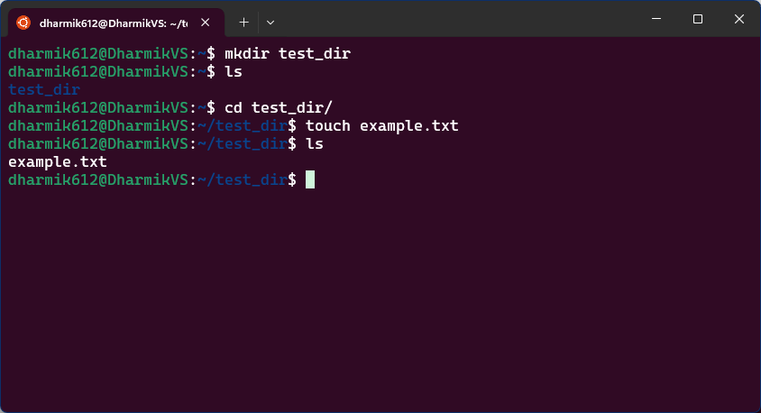
Rename example.txt to renamed_example.txt using mv
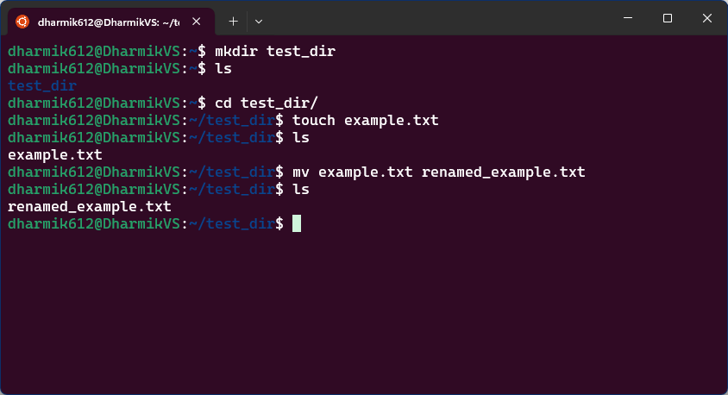
Explanation: I used mkdir to create the new directory. Then, I used touch (a standard way to create an empty file) to create example.txt inside that directory. Finally, I used the mv (move) command to rename the file to renamed_example.txt.
2. Viewing File Contents
Use cat to display the contents of /etc/passwd.
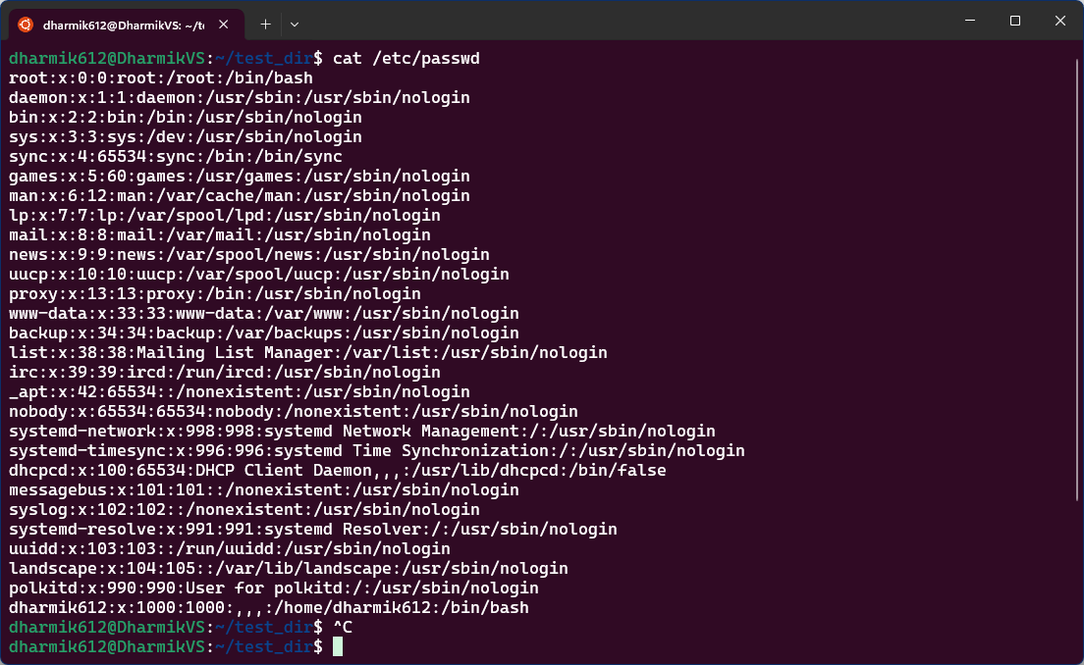
Display only the first 5 lines of /etc/passwd using head.
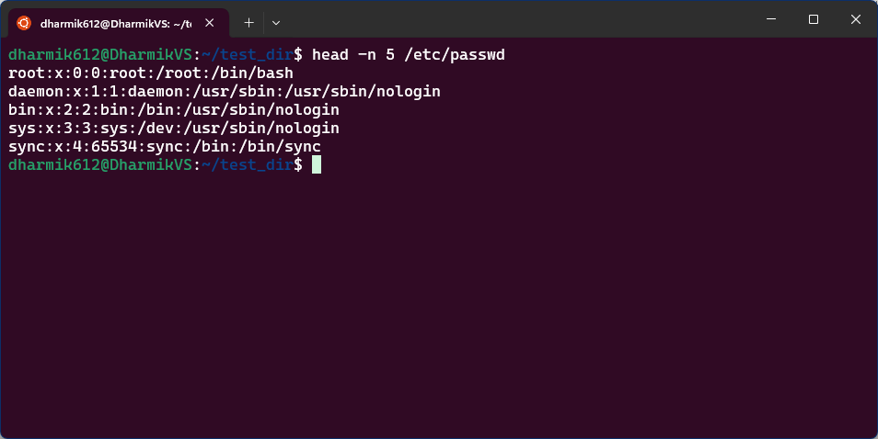
Display only the last 5 lines of /etc/passwd using tail.
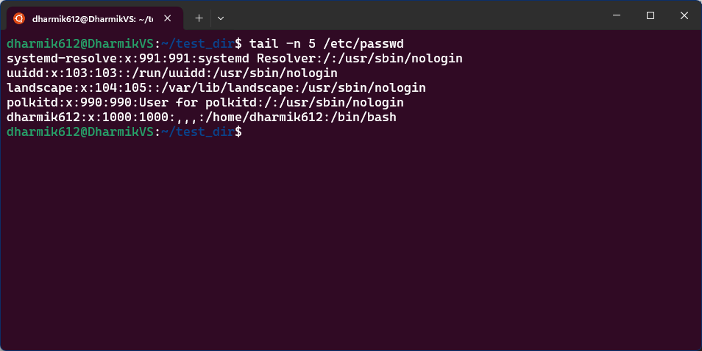
Explanation:
- cat displays the entire content of the file.
- head -n 5 displays only the first 5 lines of the file.
- tail -n 5 displays only the last 5 lines of the file.
3.Searching for Patterns
Use grep to find all lines containing the word "root" in /etc/passwd.
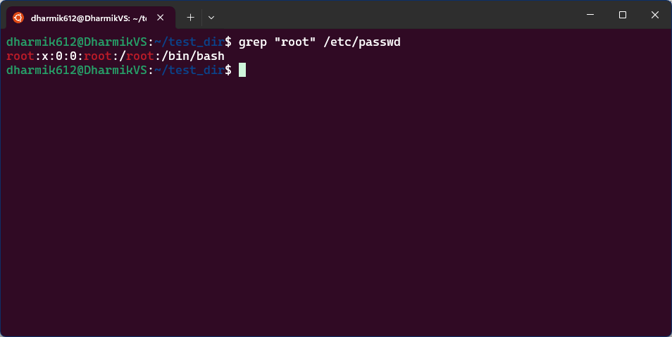
Explanation: The grep command searches for specific text patterns within a file. Here, it scanned /etc/passwd and printed only the lines that contained the string "root".
4. Zipping and Unzipping
Compress the test_dir directory into a file named test_dir.zip using zip.
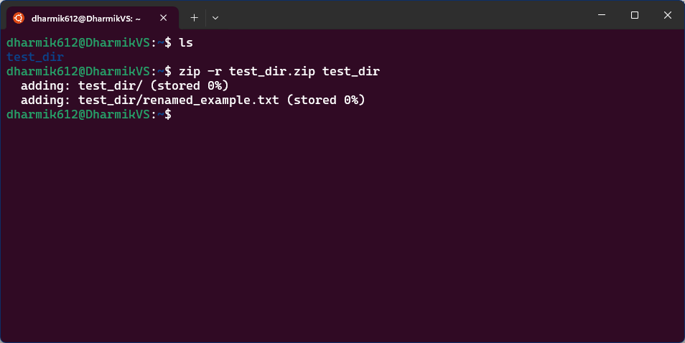
Unzip test_dir.zip into a new directory named unzipped_dir.
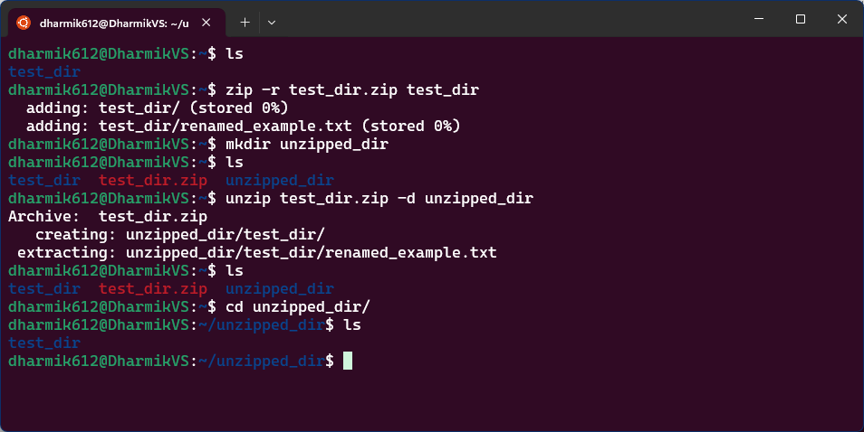
Explanation: I used zip -r (recursive) to compress the folder test_dir into a file named test_dir.zip. Then, I used unzip with the -d (destination) flag to extract the contents into a new folder called unzipped_dir.
5. Downloading Files
Use wget to download a file from a URL (e.g., https://en.wikipedia.org/wiki/DevOps).
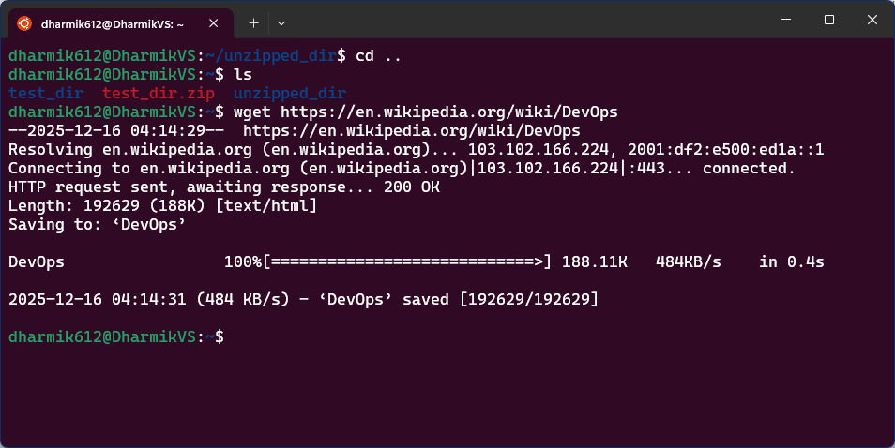
Explanation: wget is a command-line utility for downloading files from the web. It connects to the specified URL and saves the file to the current directory.

6. Changing Permissions
Create a file named secure.txt and change its permissions to read-only for everyone using chmod.
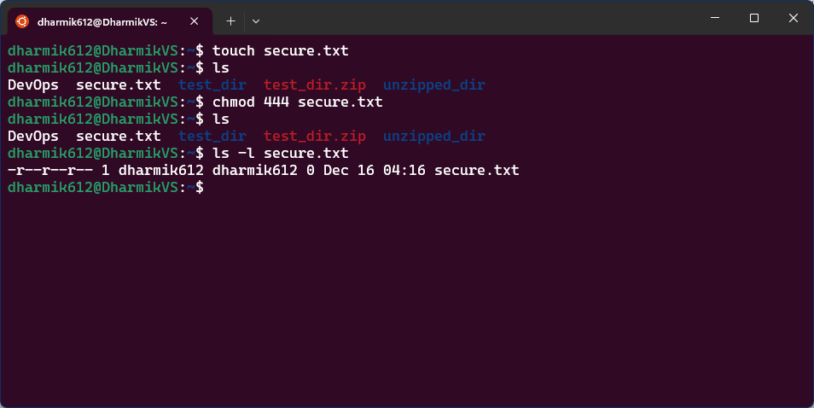
Explanation: First, I created the file. Then I used chmod 444. In octal permissions, 4 stands for "Read". Setting it to 444 grants Read permission to the User, Group, and Others, making it read-only for everyone. The ls -l command confirms the permissions are set to -r--r--r--.
7. Working with Environment Variables
Use export to set a new environment variable called MY_VAR with the value "Hello, Linux!".
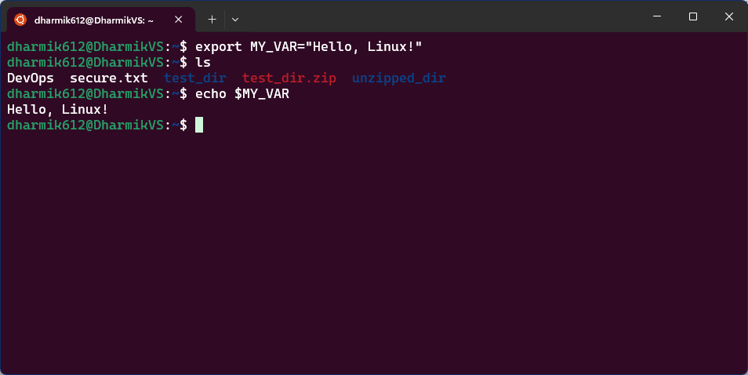
Explanation: The export command is used to set environment variables that are accessible to child processes of the shell. I verified the variable was stored correctly by printing it using echo $MY_VAR.

GitHub Repository Link: https://github.com/Dharmiks6/linux-assignment-submission.git

